VPro Quick Start
October 18, 2016

VPro runs on Microsoft Office
VPro is built using components from Microsoft Office, primarily Access and Excel but also draws on resources from other bits of Office. VPro is happiest running on Windows 7 and Office 2010 but with some coaxing can be persuaded to run on some older and newer versions.

Access is a container
The bulk of VPro resides in an Access database. You can think of the Access database as a container that can include tables, queries, forms and code. Much of your interaction with VPro will be using menu items and forms but you can also create your own custom views of the data using queries – perhaps better left until you are comfortable using Access.

Frontend / backend design
We refer to the design of VPro as a frontend/backend. The frontend is the VPro program and contains system tables, forms, queries and code modules. The backend is where your data resides. VPro is designed this way to separate your data from the program so that we can update and repair your copy of VPro without endangering your data (though we highly recommend backing up your data database(s) regularly). VPro attaches or links your data to the program and manages those links using the Data Centre menu described below.

VPro is a relational database
Your data will be organized into a series of tables that will be joined using an identification key. In a VPro project (more on projects below) this key is the plot number that you assign to each plot. The relationship between your tables is managed by VPro so that you don’t have situations where you have, for example, vegetation data without a corresponding plot record.

VPro Projects
Each VPro project contains seven tables and each has a name with an extension that informs the user as to its contents. The left portion of the name is the project name. For example, Sample_Env represents the project Sample and contains environment data. Here is a list of the extensions and the entity type for each project table:
- _Env contains data describing the plot location and attributes
- _Veg is your vegetation data
- _Humus has records for each humus soil horizon
- _Mineral has records for each mineral soil horizon
- _Other is a table that allows for customization of your project
- _Metadata contains a description of the project
- _Audit table tracks changes made to the data in form view
We will be looking at how to create, attach, un-attach and rename projects below.

VPro Menus
VPro uses two menu systems that the user uses to interact with the program. The floating Data Centre menu
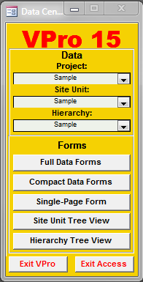
It is with this menu that you will interact with some of VPro’s most common items. VPro can have multiple projects attached and from here you can select the one you wish to work with.
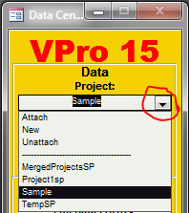
Clicking the combo box arrow will reveal the commands to attach, create and un-attach projects. It is also here that you can select from the list of attached projects.

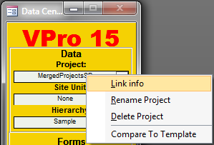
Right-clicking the project name will give you a popup menu from which you can reveal the location of the project database, rename the project, delete a project, or compare the project structure to that of the current version.
From the Data Centre you have quick access to some of the most popular data forms where you can add to and edit data.
The ribbon menu is a much more in-depth list of VPro functions giving you full access to its forms, reports and management tools.
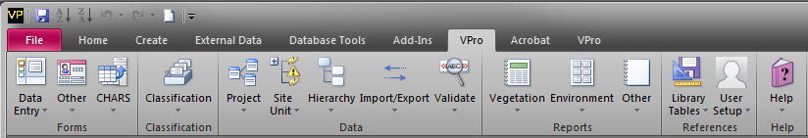

Creating your first project
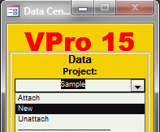
As we mentioned earlier, VPro is the frontend and your data is stored in the backend or project database. When you create a project in VPro, your data will be stored in a database of your making or choice. You will gain access to that project by links that VPro creates between VPro and your project database. To create a project using the Data Centre, click the project combo box and select New from the list.

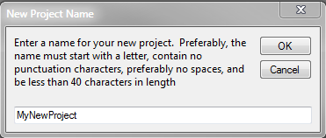
You will be asked what you want to name your project. Please read the naming suggestions on the dialog box.
Note that the name must not be in use with another attached project.

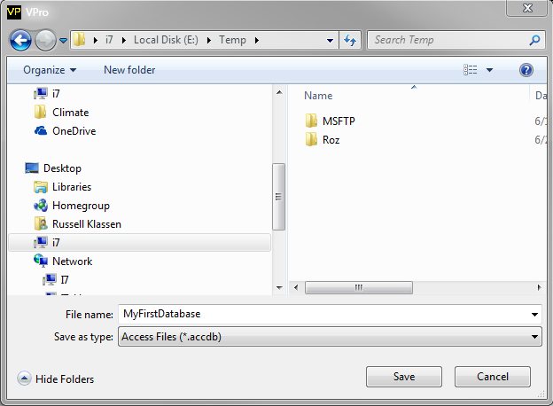
You will be asked to either locate an existing database to store your project in or, if VPro can’t find that database, VPro will create it for you.
VPro will first check the database for project name conflicts and if there are none will create your project, link to VPro, and perform some relationship steps.

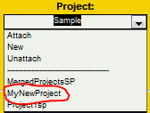
Your new project will now be available for selection. Selecting a project is sometimes refed to as making it the current project. Once you’ve made your project the current project, you are ready to start working with the data forms.

Attaching a project
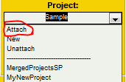
From the Data Centre select Attach in the project combo box.

A file dialog box will help you to navigate to and select the database name where the project resides. Click the Open button once you’ve selected the database.
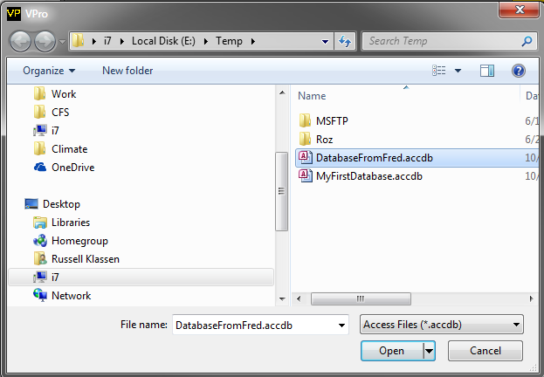
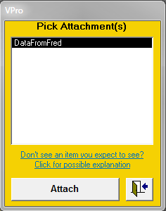
VPro will look into the database and find projects that are not currently attached and present you with a list. Select the project(s) you wish to attach and click the button Attach.
Once the project has been attached it will show up in the Data Centre project combo box.

Un-attach a project
To un-attach a project, select Unattach from the Data Centre project combo box.
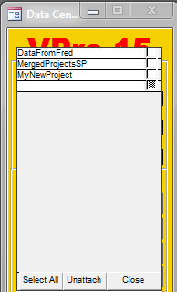
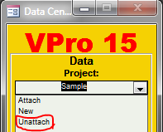

Attached projects will be listed on the form with the exception of the current project and the sample project. Select the individual projects to un-attach or click the Select All button on the form. Clicking the Un-attach button will remove the links to the selected
Note that this is not destroying the projects. You can reattach them at any time.

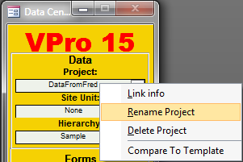
Rename a project
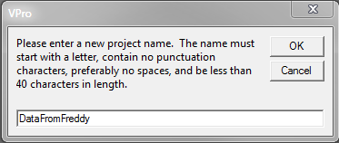
Right-clicking a project name will call a popup menu of actions that you can perform on the selected item. Click Rename Project and you will see a dialog box with the existing name. Simply edit the name and click OK.

A brief note confirming that some records in the _Audit table have been changed and the rename is complete.

Delete a project
WARNING this action permanently deletes a project and all of its data.
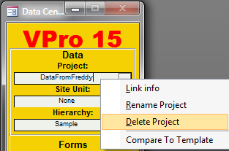
Right-click the project you wish to delete and select Delete Project. You will get one warning and that is it.
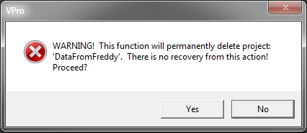

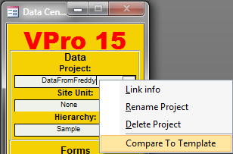
Compare to template
All things change and that is true with the structure of VPro’s data tables. Because VPro is an open architecture, changes are sometimes made to the table structure of projects without your knowledge. You can check the structure of the current project by right-clicking the project in the Data Centre and selecting Compare To Template. VPro will compare the structure of the project to the VPro standard template and report any differences.

Data forms
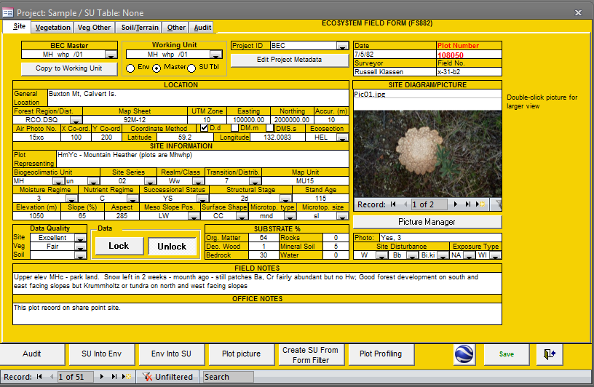
Whether you need to add data, edit data or just view the data, data forms makes your data accessible and organized. Select from one of the common forms available from the Data Centre or, for a wider variety, check out the Forms section on the VPro ribbon menu.

Site unit table
The site unit table subject is too large to present in this quick start document. But for now you can think of the site unit table as a single level method to group and filter plots.

Hierarchy table
Like the site unit table, the hierarchy table subject is too large to present here. The hierarchy table allows the user to use a multi-level method to group plots.

Some last words
The preceding information was just enough to get you started with VPro projects. By using these help files and what you’ve learned here, we hope that you use the sample data to explore further.

